**Front End Web Development**

**Project 3**

**S. Bacot**

**NOTES & CREDITS**

1. RESTAURANT Page

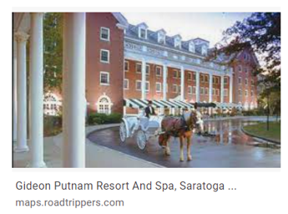

"img/gideonputnamentrancenight2.jpg" (cCegQIABAA&oq=images%2C+gideon+putnam&gs_lcp=CgNpbWcQA1ChNVi3c2CJdmgAcAB4AIABf4gBzQ2SAQQyMS4xmAEAoAEBqgELZ3dzLXdpei1pbWfAAQE&sclient=img&ei=OgMCYtnrM_DgytMPz9qywAU&bih=641&biw=1422&rlz=1C1JZAP_enUS894US894)

2.

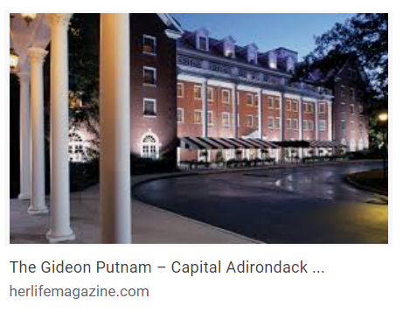

"img/gideonputnamentrancenight3.jpg"

(<https://www.google.com/search?q=images%2C+gideon+putnam&tbm=isch&ved=2ahUKEwjZ8KKus-_1AhVwsHIEHU-tDFgQ2-cCegQIABAA&oq=images%2C+gideon+putnam&gs_lcp=CgNpbWcQA1ChNVi3c2CJdmgAcAB4AIABf4gBzQ2SAQQyMS4xmAEAoAEBqgELZ3dzLXdpei1pbWfAAQE&sclient=img&ei=OgMCYtnrM_DgytMPz9qywAU&bih=641&biw=1422&rlz=1C1JZAP_enUS894US894>)

3.

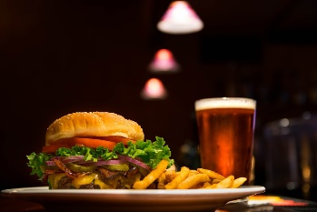

“edward-franklin-Nb_Q-M3Cdzg-unsplash Burger and Beer 2 6 22.jpg”

**Edward Franklin,** Download free, beautiful high-quality photos curated by Edward. [Eugene, OR](https://unsplash.com/s/photos/eugene%2C-or) [Instagram](https://instagram.com/eddie2oh) (<https://images.unsplash.com/photo-1457460866886-40ef8d4b42a0?ixlib=rb-1.2.1&ixid=MnwxMjA3fDB8MHxzZWFyY2h8MXx8YnVyZ2VyJTIwYW5kJTIwYmVlcnxlbnwwfHwwfHw%3D&auto=format&fit=crop&w=600&q=60>)

4.

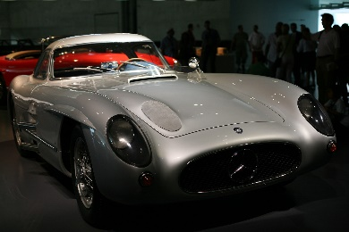

"img/automobile-gfed46634e_1920 museum car 2 2 22.jpg" (https://pixabay.com/photos/automobile-sports-car-mercedes-6067731/)

5.

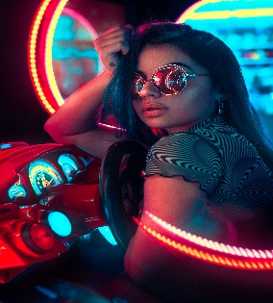

"img/wilmer-martinez-zLlXblupecM-unsplash arcade1 2 7 22.jpg," Photo by [Wilmer Martinez](https://unsplash.com/@wilmerlens?utm_source=unsplash&utm_medium=referral&utm_content=creditCopyText) on [Unsplash](https://unsplash.com/s/photos/arcade?utm_source=unsplash&utm_medium=referral&utm_content=creditCopyText) (<https://images.unsplash.com/photo-1580428180123-313752d0f0f3?ixlib=rb-1.2.1&ixid=MnwxMjA3fDB8MHxwcm9maWxlLXBhZ2V8Nnx8fGVufDB8fHx8&auto=format&fit=crop&w=600&q=60>)

6.

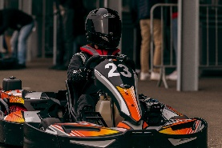 **Bastien Plu-**I'm photographer living in France. I've many field like sport, corporate, portrait, wildlife, animal and more. You can see a lot of my work here and on my different link. https://linktr.ee/BastienPluPhotographe

Available for hire

[Support via PayPal](https://www.paypal.com/donate?business=bastien.plu%40icloud.com&item_name=Bastien%20Plu%20-%20Unsplash&currency_code=USD)

[Le Mans, France](https://unsplash.com/s/photos/le-mans%2C-france)

Connect with Bastien

"img/bastien-plu-CUt2SVsDbk4-unsplash kart racer2 2 6 22.jpg" (https://images.unsplash.com/photo-1641473076702-e9fed7a169a4?ixlib=rb-1.2.1&ixid=MnwxMjA3fDB8MHxzZWFyY2h8MTN8fGthcnQlMjByYWNlcnxlbnwwfHwwfHw%3D&auto=format&fit=crop&w=600&q=60)

7.

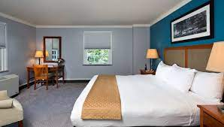

"img/gideonputnam-putnam-suite-2-lg.jpg"

(https://www.google.com/search?q=images%2C+gideon+putnam&tbm=isch&ved=2ahUKEwjZ8KKus-_1AhVwsHIEHU-tDFgQ2-cCegQIABAA&oq=images%2C+gideon+putnam&gs_lcp=CgNpbWcQA1ChNVi3c2CJdmgAcAB4AIABf4gBzQ2SAQQyMS4xmAEAoAEBqgELZ3dzLXdpei1pbWfAAQE&sclient=img&ei=OgMCYtnrM_DgytMPz9qywAU&bih=641&biw=1422&rlz=1C1JZAP_enUS894US894)

8.

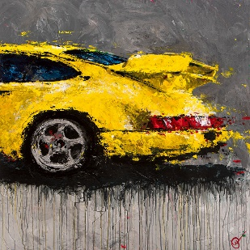Abstracted Air - The Artwork Of Lyn Hiner On Display

Featuring the varied paintings of celebrated automotive artist Lyn Hiner.

"img/ABSTRACTED AIR BY LYN HINER.png" (http://www.saratogaautomuseum.org/current-exhibitions)

1. MENU Page

1.

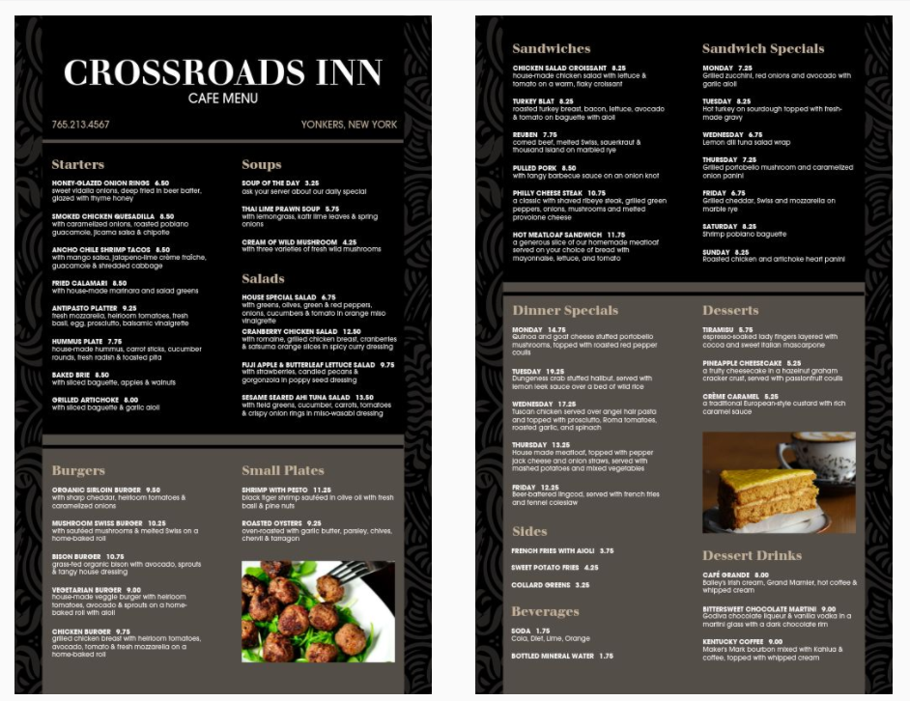

“https://renderer.mhme.nu/design/thumbnail/15fd0406-d7fe-4f8f-a8e7-89685b7ee8a9?width=500&update=1644271615419&page=2”

https://www.musthavemenus.com/menu-template/elegant-hotel-menu.html?cat=7534

1. ACTIVITIES Page

1.

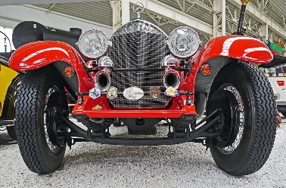

"img/mercedes-g83c817a30_1920 museum car 2 2 22.jpg" (<https://pixabay.com/photos/mercedes-spider-roadster-race-car-1336383/>)

2.

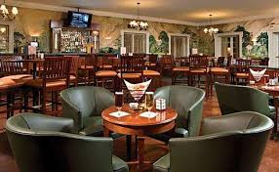

"img/gideonputnamgreenlounge.jpg" (<https://www.google.com/search?q=images%2C+gideon+putnam&tbm=isch&ved=2ahUKEwjZ8KKus-_1AhVwsHIEHU-tDFgQ2-cCegQIABAA&oq=images%2C+gideon+putnam&gs_lcp=CgNpbWcQA1ChNVi3c2CJdmgAcAB4AIABf4gBzQ2SAQQyMS4xmAEAoAEBqgELZ3dzLXdpei1pbWfAAQE&sclient=img&ei=OgMCYtnrM_DgytMPz9qywAU&bih=641&biw=1422&rlz=1C1JZAP_enUS894US894>)

3.

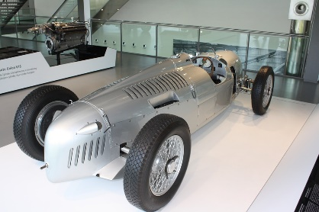

"img/automuseumracecarsilver.jpg" (<https://pixabay.com/photos/autostadt-wolfsburg-wolfsburg-museum-1104140/>)

4.

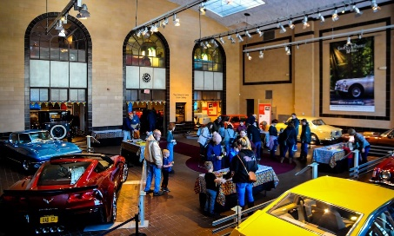

"img/Racehouseentrance2.jpg" (https://saratogaliving.com/wp-content/uploads/2020/01/image001-1.jpg)

5.

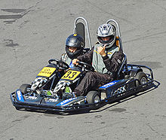

This image as well as specific information on Go Karts, engines, tracks were obtained from Wikipedia. (https://en.wikipedia.org/wiki/Go-kart)

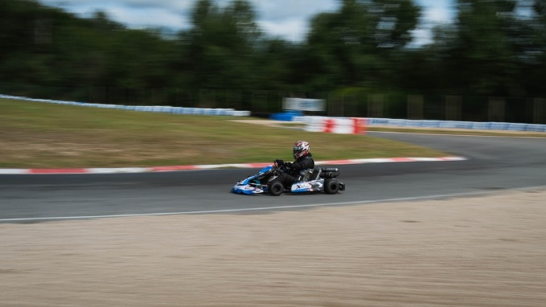

Photo by [Nicolas Peyrol](https://unsplash.com/@nicolaspeyrol?utm_source=unsplash&utm_medium=referral&utm_content=creditCopyText) on [Unsplash](https://unsplash.com/s/photos/kart-race?utm_source=unsplash&utm_medium=referral&utm_content=creditCopyText)

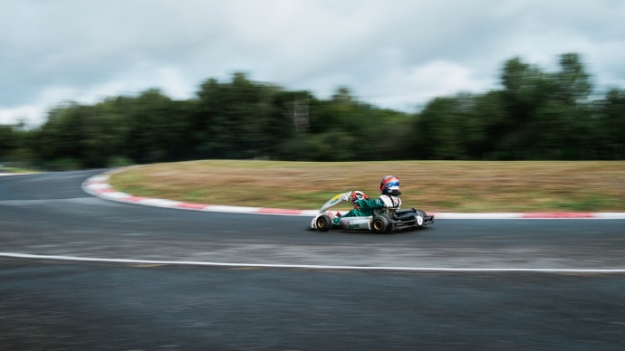

Photo by [Nicolas Peyrol](https://unsplash.com/@nicolaspeyrol?utm_source=unsplash&utm_medium=referral&utm_content=creditCopyText) on [Unsplash](https://unsplash.com/s/photos/kart-race?utm_source=unsplash&utm_medium=referral&utm_content=creditCopyText)

1. LOCATION Page
2. ACCESSIBILITY Page